 

INSTITUTE FOR ADVANCED COMPUTING AND SOFTWARE

DEVELOPMENT AKURDI, PUNE

Documentation On

**“Online Food Ordering System”**

PG-DAC SEPTEMBER 2021

*Submitted By*

**Group No: 74**

**Rohini Padhye - 219148**

**Nikita Shrivastava – 219114**

*Project Guide*

**Mr. Milind Arjun(External)**

**Mrs. Sonali Mogal(Internal)**

*Center Coordinator*

**Prashant Karhale**

***INDEX***

1. **Introduction .....................................................................................................................3**
2. **Requirement Specification..............................................................................................4**
3. **System Diagram ..............................................................................................................8**
4. **Table Structure ..............................................................................................................13**

**Advantages………...............................................................................................................15**

**Disadvantages……..............................................................................................................16**

**Conclusion ...........................................................................................................................17**

1. **References ......................................................................................................................17**

***CHAPTER 1: INTRODUCTION***

***1.1 INTRODUCTION***

The project Online Food ordering system is a web based application that allows the administrator to handle all the activities online quickly and safely. Using this, the administrator doesn’t have to sit and manage the entire activities on paper, and at the same time, the head will feel comfortable to keep check of the whole system. This system will give him power and flexibility to manage the entire system from a single online portal.

***1.2 AIM***

Our proposed system is an online food ordering system that enables ease for the customers. It overcomes the disadvantages of the traditional queuing system. Our proposed system is a medium to order online food hassle free from restaurants as well as mess service. This system improves the method of taking the order from customer. The online food ordering system sets up a food menu online and customers can easily place the order as per their wish. Also with a food menu, customers can easily track the orders. This system also provides a feedback system in which user can rate the food items. Based on the ratings given by the user, the restaurant staff can make improvements. The payment can be made online or cash mode. For more secured ordering separate accounts are maintained for each user by providing them an ID and a password.

***1.3 Modules of Project:***

***1. Admin:***

This module is responsible for adding products to menu, adding offers if any, managing customers, checking orders and payments.

***2. User:***

User is actually is customer who is placing his/her order online. User can choose from menu, add to cart and make payment either online or cash at store.

***CHAPTER 2: Requirement Specification***

***System Model:***

The structure of the system can be divided into three main logical components. The first component must provide some form of menu management, allowing the restaurant to control what can be ordered by customers. The second component is the web ordering system and provides the functionality for customers to place their order and supply all necessary details. The third logical component is the order checking/retrieval system. It will be used by restaurant owners/admin to keep track of all the orders placed, orders cancelled or in short knowing status of orders.

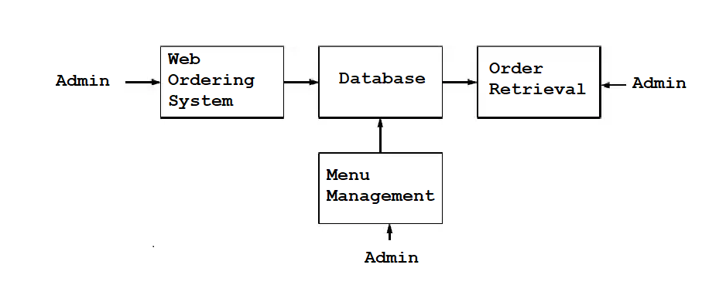

***Web Ordering System:***

Users of web ordering system must be provided little functionalities:

* Create account.
* Manage their account.
* Login to System.
* Navigate through Menu Page
* Add an item from menu to cart.
* Remove an item/remove all items from their current order.
* Review their current order.
* Place an order.

***Order Retrieval System:***

Like the menu management system, it is designed to be used only by restaurant employees, and provides the functions:

* Retrieve the orders.
* Display the orders easily readable.
* Mark an order as having been processed and remove it from list of active users.

To view the details of order the user must simply click on that order number, which will populate the details of that order.

***Menu Management System:***

Admin can add delete the products from a particular category. Admin can manage offers for different dishes listed on Menu.

***Functional Requirement Specifications:***

*Registration:*

Registration is required for both Admin and Customer. Both needs to register under their specific category to further access page and perform desired activity.

*Login:*

Once the Registration is done, Admin and Customer can login using Login option by giving their emailed and password given at time of registration.

*Logout:*

Once the page is accessed by any of be it Admin or Customer, they may logout using Logout option provided on page.

*Payment Gateway:*

A secure payment gateway is provided for customers so that they experience smooth and hassle-free transactions and also it reaches to owner/Admin.

***Non-Functional Requirement:***

*Reliability:*

The ability of the system to behave consistently in a user acceptable manner when operating within the environment for which system was intended.

*Accessibility:*

The system should be available at all times, meaning the user can access it using a web browser.

*Security:*

The web application shall ensure sensitive information is secure, such as user address, payment mode details, card details, contact number. Non-registered members will not be able to access the functionalities.

*Portability:*

System running on one platform can easily be converted to run on another platform.

*Maintainability:*

A database used for maintaining the db and application server takes care of the site.

*User Friendly:*

System should be easily used by the customer.

*Performance:*

Performance should be the best of it’s nature, which will also lead to attracting customers.

*Efficient:*

System should be efficient that it won’t get hang if heavy traffic of order is placed.

*Safety:*

Data in the database of system should not loss or damage.

*Privacy:*

Personal data of the system should not be disclosed to anyone.

***Chapter 3: System Diagrams***

***Use Case Diagram:***

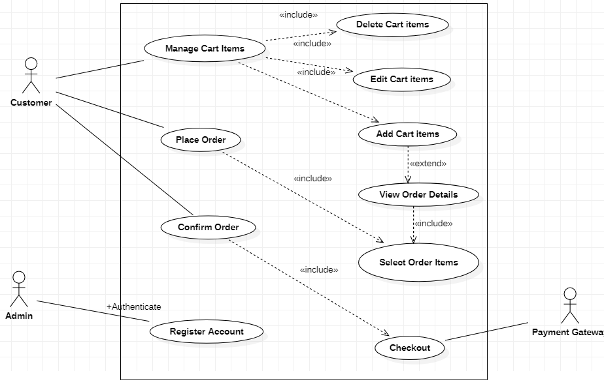

***E-R Diagram:***

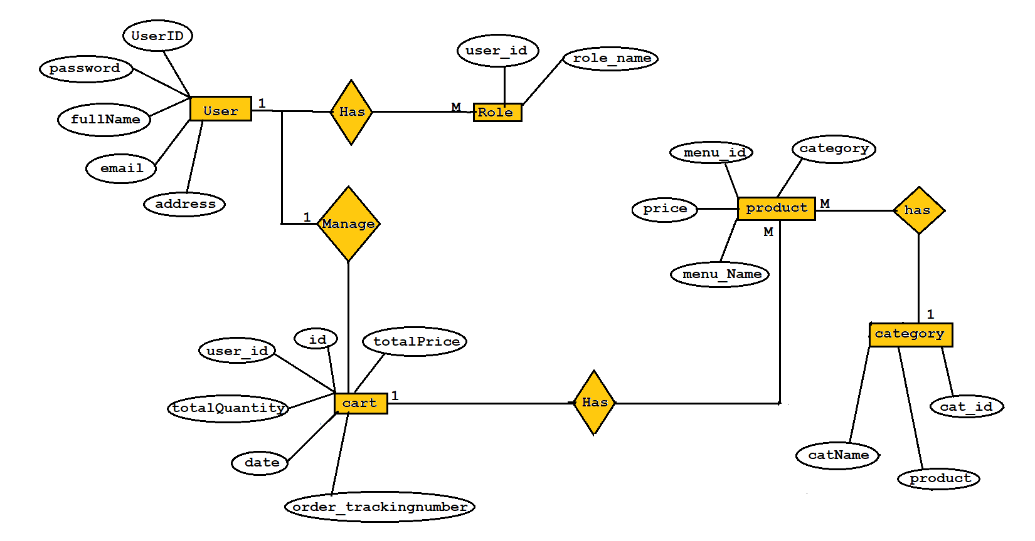

***Data Flow Diagram:***

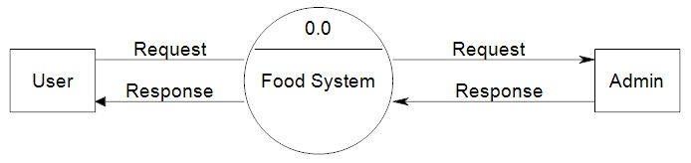

**Level 0**

***User Level DFD:***

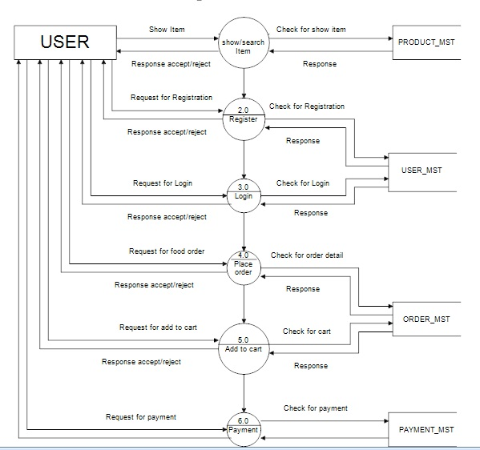

*Admin Level DFD:*

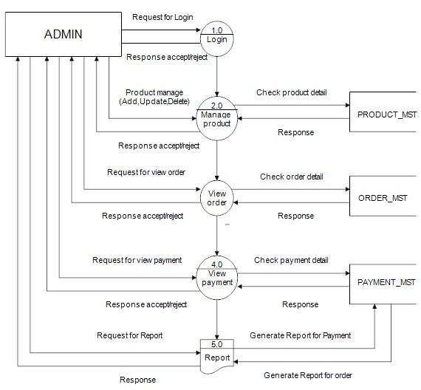

***Class Diagram:***

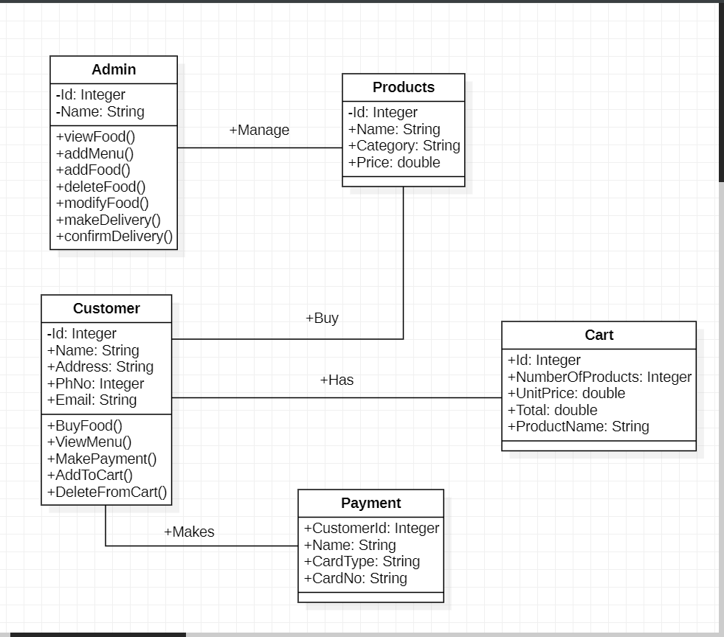

***Chapter 4: Table Structure***

***User Table:***

|  |  |  |  |  |  |
| --- | --- | --- | --- | --- | --- |
| **Field** | **Type** | **Null** | **Key** | **Default** | **Extra** |
| Id | bigInt | NO | PRI | NULL | Auto_increment |
| full_Name | varchar(255) | NO |  | NULL |  |
| email | varchar(255) | NO | UNI | NULL |  |
| password | varchar(255) | NO |  | NULL |  |
| address | varchar(255) | NO |  | NULL |  |
| role_id | bigInt | NO | MUL | NULL |  |

***Roles Table:-***

|  |  |  |  |  |  |
| --- | --- | --- | --- | --- | --- |
| **Field** | **Type** | **Null** | **Key** | **Default** | **Extra** |
| Id | bigInt | NO | PRI | NULL | Auto_increment |
| Name | varchar(255) | NO |  | NULL |  |

***Category Table:-***

|  |  |  |  |  |  |
| --- | --- | --- | --- | --- | --- |
| **Field** | **Type** | **Null** | **Key** | **Default** | **Extra** |
| cat_id | bigInt | NO | PRI | NULL | Auto_increment |
| cat_name | varchar(255) | NO |  | NULL |  |

***Product Table:-***

|  |  |  |  |  |  |
| --- | --- | --- | --- | --- | --- |
| **Field** | **Type** | **Null** | **Key** | **Default** | **Extra** |
| menu_id | bigInt | NO | PRI | NULL | Auto_increment |
| menu_name | varchar(255) | NO |  | NULL |  |
| img_url | varchar(255) | NO | UNI | NULL |  |
| price | double | NO |  | NULL |  |
| cat_id | bigInt | No | MUL |  |  |

***Order Table:-***

|  |  |  |  |  |  |
| --- | --- | --- | --- | --- | --- |
| **Field** | **Type** | **Null** | **Key** | **Default** | **Extra** |
| orders_id | bigInt | NO | PRI | NULL | Auto_increment |
| date_created | datetime(6) | NO |  | NULL |  |
| order_tracking_  number | varchar(255) | NO | UNI | NULL |  |
| total_price | double | NO |  | NULL |  |
| total_quantity | int | NO |  | NULL |  |
| user_id | bigint | NO | MUL |  |  |

***Advantages of online food ordering system***

***Easy communicative***

The online food ordering service is a local restaurant and food cooperative website or application for customers. Due to the rapid growth of smart phone and internet usage and the technologies associated with it so many restaurant are now undertaking their business to online to know more about customer choices and experiences using their feedback.

***Time saving***

The online food ordering is now days popular among the young generation comfortable, time saving and convenient. If a consumer makes a mind to purchase online food he or she has multiple food items option or menu card online. The main identified factors are time saving and convenience. People compare prices in online food delivery website and apps selection of the dish. The restaurants have to make proper strategies to increase the consumer level of satisfaction.

***Disadvantages of online food ordering system***

***Cost of increase***

Online food ordering system service nowadays increase your budget. Because of need a new delivery team to provide the services and you need to spend extra charges. In this system all type expense can be transfer on consumers.

***Change of environment***

The main different between the online food ordering and dining in a restaurant is the environment around us.The comfort is really high level of online food take away. One who is fond of dine-in luxury restaurant with super design and light music that environment gives better relax compared to the other.

***CONCLUSION***

Online Food Ordering system is done to help and solve one of the important problems of customer of the standing in queues and waiting for orders . Customers using the internet and phone can place order from anywhere and pick it up as per their convenience. Thus, implementation of Online Food Ordering system is done to help and solve problems of customers as well as restaurant owners. It helps customer in making order easily and gives information needed in making order to customer place. The Food website application made for restaurant massive one help to receiving orders.

***References***

1. <https://www.researchgate.net/publication/350430883_ONLINE_FOOD_ORDERING_SYSTEM>
2. <https://www.slideshare.net/FatimaQayyum1/srs-software-requirement-specification-document>
3. <https://www.coursehero.com/file/53977776/food-ordering-docx/>
4. <https://www.scribd.com/oauth>
5. https://www.w3schools.com/
6. https://www.javatpoint.com/java-mail-api-tutorial